DeepSeaNet: Improving Underwater Object Detection using EfficientDet
  - Sanyam Jain
Østfold University College,
Halden, 1783, Norway,
sanyamj@hiof.no

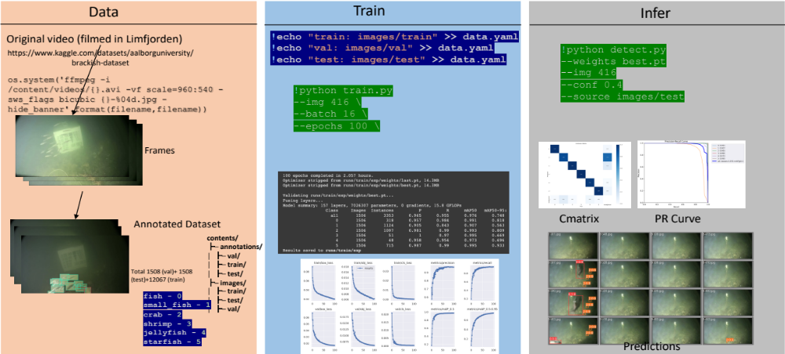
1-Abstract
Marine animals and deep underwater objects are difficult to recognize and monitor for safety of aquatic life. There is an increasing challenge when the water is saline with granular particles and impurities. In such natural adversarial environment, traditional approaches like CNN start to fail and are expensive to compute. This project involves implementing and evaluating various object detection models, including EfficientDet, YOLOv5, YOLOv8, and Detectron2, on an existing annotated underwater dataset, called the Brackish Dataset. The dataset comprises annotated image sequences of fish, crabs, starfish, and other aquatic animals captured in brackish water with varying visibility. The aim of this research project is to evaluate the performance of newer models on the same dataset and compare them with the previous results based on accuracy and inference time. Firstly, I compare the results of YOLOv2 (31.10% mean Average Precision (mAP)), YOLOv3 (83.72% mAP), YOLOv5 (97.6%), YOLOv8 (98.20%), EfficientDet (98.56% mAP) and Detectron2 (95.20% mAP) on the same dataset. Secondly, I provide a modified BiSkFPN mechanism (BiFPN neck with skip connections) to perform complex feature fusion in adversarial noise which makes modified EfficientDet robust to perturbations. Third, analyzed the effect on accuracy of EfficientDet (98.63% mAP) and YOLOv5 by adversarial learning (98.04% mAP). Last, I provide class-activation-map based explanations (CAM) for the two models to promote Explainability in black box models. Overall, the results indicate that modified EfficientDet achieved higher accuracy with five-fold cross validation than the other models with 88.54% IoU of feature maps.

Keywords: Object Detection, YOLO, EfficientDet, Faster RCNN, Maritime Dataset, GradCAM

2-Introduction
Automated Maritime Object Detection and Marine Vision (AMODMV) [1] helps in scientific research and deep underwater wildlife exploration. It ensures safe navigation to avoid potential collisions with seabed objects, environmental protection by identifying and tracking pollution, preventing-preserving flora and fauna of aquatic life and security in international waters by detecting and tracking boats and ships that may be engaged in illegal activities like smuggling or piracy. This has much larger application usage for ensuring the safety of ships and crew, conducting search and rescue operations. Huge impact on aquatic life, due to pollution, overfishing, invasive species, and infrastructure intervention leads to loss of biodiversity, imbalance of food chain, and contamination of sea food. Therefore, requirement of continuous monitoring, controlled fishing, counting population, and identifying individual species is key to conserve and protect our resources. A quick overview of my complete working pipeline is shown in Figure 1. Details are further discussed in the remaining paper.
Figure 1 An overview of my Object Detection Working Pipeline followed for YOLO, EfficientDet and Detectron2
While performing AMODMV, biggest challenge is the noisy images (limited visibility) because of the impurities of water, wrong placement angles of image sensing kits, and interpreting the results from the object detection model. In addition, The marine environment is often cluttered with a variety of objects, such as rocks, plants, and debris, which can make it difficult to distinguish between objects of interest and background clutter [2,3]. I experimented and proved the hypothesis, “Can we learn a noisy deep-sea imagery using a real world recorded video with the help of annotations using EfficientDet algorithm performed on the Brackish Dataset?” to be true. Not only statistical proves, but I also provide saliency map and CAM based results that prove model has learned correct class specific features with respective confidence percentage. More advanced combinations and tricks are performed during the experiment using Adversarial Learning for higher accuracy (along with Precision and Recall). In the best of my knowledge, this work is the first attempt to improve the baseline of the Brackish Dataset [15].
One Stage Object Detector (OSOD) and Two Stage Object Detectors (TSOD) have reportedly proven better than traditional approaches of Object Detection (for e.g., sliding window method, SIFT and HOG). OSOD models (for e.g., YOLO), can quickly and accurately detect objects in a single pass. They achieve this by predicting the class and location of objects using a single network architecture. However, one-stage models can struggle with accurately detecting small objects or objects with complex shapes. TSOD such as Faster R-CNN and Mask R-CNN, take a different approach. These models first generate a set of region proposals, which are likely locations for objects in the image. They then classify and refine these proposals to determine the final object detection. This approach allows for more accurate detection of small objects or objects with complex shapes but is generally slower than one-stage models [4,5].
Single-stage object detectors, such as YOLO (You Only Look Once) [6] and EfficientDet [7], have become increasingly popular in object detection tasks due to their speed, accuracy, and efficiency. YOLO uses a single-stage detection pipeline that consists of a backbone, neck, and head. The backbone is typically a feature extractor, such as DarkNet-53 or CSPDarkNet-53 [8], that extracts feature from the input image. The neck module, such as FPN [9] or PANet [10], is responsible for fusing features across different levels of the network, which helps to improve the detection performance of small and large objects. The head then performs the final detection task, which involves predicting bounding boxes and object classes directly from the feature maps.
EfficientDet is a variant of YOLO that uses an efficient backbone network and a BiFPN (Bidirectional Feature Pyramid Network) [7] to fuse features across different levels of the network. EfficientDet is known for balancing the speed vs accuracy tradeoff and cheap parameter space. The backbone is a compound scaling of EfficientNet [11] that consists of a series of efficient building blocks, such as MBConv, that are optimized for a small computational budget. The modified BiSkFPN mechanism improves feature fusion in adversarial noise by using a skip connections and weighted average of the features in the top-down and bottom-up pathways. This makes EfficientDet more robust to perturbations and more accurate than other single-stage detectors. The BiFPN also includes skip connections that allow the network to use high-resolution feature maps for small objects and low-resolution feature maps for large objects, which improves the detection performance across a wide range of object sizes.
Two-stage object detection methods, such as Faster R-CNN [12] and Mask R-CNN [13], are not suitable for AMODMV due to their high computational requirements and slow inference time. On the other hand, single-stage object detection methods are faster and more efficient, making them better suited for this application. EfficientDet has shown to perform better than other single-stage object detection models such as YOLOv5 and Detectron2 [14] on the Brackish Dataset [15]. This is due to its efficient backbone network, BiSkFPN mechanism which allow it to effectively deal with the challenges posed by the marine environment.

2.1-Contributions
In this section, I present the contributions of my research project aimed at improving underwater object detection using state-of-the-art object detection models and techniques:
- Comparative evaluation of state-of-the-art object detection models: The project involves a comparative evaluation of various object detection models, including EfficientDet, YOLOv5, YOLOv8, and Detectron2, on an existing annotated underwater dataset. This evaluation helps to identify the most effective model for underwater object detection.
- Development of a modified BiSkFPN mechanism: The project proposes a modified BiSkFPN mechanism, which involves using a BiFPN neck with skip connections, to perform complex feature fusion in adversarial noise. This mechanism makes the modified EfficientDet model more robust to perturbations and improves its accuracy.
- Adversarial learning for improved object detection accuracy: The project analyzes the effect of adversarial learning on the accuracy of EfficientDet and YOLOv5. This analysis helps to identify the most effective training strategy for underwater object detection.
- Explainability in black box models: The project provides class-activation-map based explanations (CAM) for EfficientDet and YOLOv5 to promote Explainability in black box models. These explanations help to improve the interpretability of the models and enhance their trustworthiness.
- Improved performance in AMODMV: The project demonstrates that modified EfficientDet achieved higher accuracy with five-fold cross-validation than other models. The use of EfficientDet improves the accuracy and reliability of AMODMV, which can enhance maritime security, monitor the environment, and protect aquatic life.

3-Related work
This section presents summaries of my study on modified architectures specially for complex computer vision techniques and monitoring applications. Firstly, I review five recent works that has used EfficientDet algorithm along with other OSOD. Secondly, I study FPN, PANet and BiFPN bottlenecks used in OSOD algorithms. Finally, I study several concepts form XAI that will be used in later parts of the paper.

3.1-mynet: Improved EfficientDet using Attention Mechanism (AM) – Multiclass Focal Loss (MFL):
A new method that uses AM to dampen the effect of noise (caused by pollution, clouds, and climate) in remote sensing images. This work [16] also modifies pooling in every layer such that it can capture tiny class specific pixels and hence uses exhaustive feature space. This approach increases computational complexity but helps to achieve higher accuracy. It is because of the residual deformable 3-D convolution (RD3C) which extends the traditional 2-D convolution operation to better capture object deformations and variations in 3-D data (for e.g., space imagery or remote sensing). Two basic operations that are used in the work are 3D-Convolutional operation and Geo-Spatial Deformable-3D Convolutional Operation which is further explained in the following equations. The standard 3D convolution operation can be represented as:
$$y_{i,j,k}=\sum_{d=-D}^{D}{\sum_{h=-H}^{H}{\sum_{w=-W}^{W}{x_{i+d,j+h,k+w}}}}⋅k_{d,h,w}$$
where $x$ is the input volume, $y$ is the output volume, $k$ is the convolution kernel, and $D$, $H$, and $W$ are the depth, height, and width of the kernel, respectively. In RD3C, the 3D deformable convolution operation is introduced before the standard 3D convolution, which can be represented as:
$$z_{i,j,k}=\sum_{d=-D}^{D}{\sum_{h=-H}^{H}{\sum_{w=-W}^{W}{x_{i+d,j+h,k+w}}}}⋅k_{d,h,w}+\sum_{p=1}^{P}{\sum_{q=1}^{Q}{\sum_{r=1}^{R}{x_{i+p,j+q,k+r}}}}⋅Δk_{p,q,r}$$
where $z$ is the intermediate feature map obtained by the deformable convolution operation, $P$, $Q$, and $R$ are the depth, height, and width of the offset kernel, respectively, and $Δk$ is the learnable deformation offset applied to the kernel. The deformation offset is learned from the input features using a separate convolutional operation, which can be represented as:
$$Δk_{p,q,r}=\sum_{n=1}^{N}{f_{n}\left(x_{i+p,j+q,k+r}\right)}⋅ω_{n,p,q,r}$$
where $f_{n}$ is the feature extraction function applied to the input features, $ω_{n}$ is the set of learnable weights associated with the $n^{th}$ feature channel, and $N$ is the number of feature channels. RD3C allows the convolution kernel to be adaptively adjusted to the input features, which can better capture the variations and deformations in 3D data, making it well-suited for object detection tasks in high-resolution remote sensing images of oil storage tanks.

3.2-Comparing YOLOv5 and EfficientDet
Mekhalfi et al., [17] initially perform a contrastive study and provides enough evidence that proves, even though EfficientDet results higher mAP but YOLOv5 can detect more examples and has better generalization capabilities. They reproduce results on EfficientDet and list out intuitions behind using BiFPN over FPN as follows:
- Including nodes with one input edge will have a smaller contribution in feature fusion. (Yellow nodes in Figure 2)
- Extra edge ties the input node to the output node. (Green and Black edges from input to output nodes)
- Each bidirectional path is considered as one feature layer, repeated several times to enable high-level feature fusion. (Up down arrows in Figure 2)
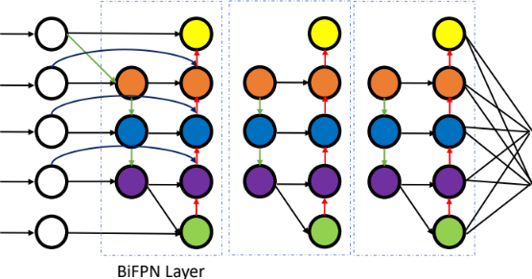
Figure 2 BiFPN Feature-Fusion (Bottleneck of original EfficientDet)
3.3-Automated Defect Detection: Modifying Backbone
Even though Medak et al., in [18] agree that object detection algorithms require large amount of data to provide human-level accuracy, they prove EfficientDet to be able to perform SOTA results on realistic performance in Ultrasonic and Forensics defect detection. They introduce a novel anchors (sliding window) size finding mechanism for OSOD, a kind of hyperparameter search. Anchors are predefined rectangles used by one-stage detectors to predict object locations and sizes. In this case, the hyperparameters are calculated using a novel procedure that considers the aspect ratio of the defects in UT images. This improves the detection of defects with extreme aspect ratios and increases the model's average precision. The complete novelty of this approach can be explained with the following Algorithm 1. It involves K-means clustering with Jaccard distance to calculate new values for aspect ratios and scales, and finding the template anchor size that is most like the calculated shape to determine the scale factor. The final values greatly differ from commonly used default values and were found to improve the performance of the EfficientDet model in detecting defects.
3.4-Multilayer 3D Attention Mechanism
The combination of feature fusion with multilayer attention helps to extract features from low-level visibility keeping feature channel intact for multi-scale inputs. This research work [19] proposed a method for classifying military ships from high-resolution optical remote sensing images using a multilayer feature extraction network inspired by EfficientDet trackers. In the proposed method, a multilevel attention mechanism was used to effectively extract multilayer features, and a deep feature fusion network was constructed to locate and distinguish different types of ships. In contrast, our approach for marine animal and species detection uses a modified EfficientDet network with skip connections to improve accuracy, rather than using the proposed method. Residual connections are a type of skip connection used in deep neural networks, but they have some limitations compared to standard skip connections.


Algorithm 1 This algorithm calculates the aspect ratios and scales for EfficientDet anchors using K-means with the Jaccard distance metric on a list of bounding boxes, and merges similar scales to produce the final list of hyperparameters.
A simple architecture of both where a simple XOR is performed for input and output of previous layer in residual connection, however a connection is broken in skip connection which is shown by dashed line in Figure 3. Residual connections can help with the vanishing gradient problem and improve the performance of deep neural networks, but they are not as effective as skip connections in some cases. Skip connections are more flexible and can learn complex representations better than residual connections, especially when the number of layers is large. In general, the choice of which to use depends on the specific problem being addressed, therefor for our application we use skip connections.

Figure 3 Residual connections add the original input to the output of the previous layer, while skip connections concatenate the input and output of the previous layer.
3.5- Another FashionNet
In the field of fashion image analysis, deep learning models with high computational requirements have been a challenge. To address this, the proposed study [20] presents a one-stage detector that can rapidly detect multiple clothes and landmarks in fashion images. The study modifies the EfficientDet network and applies compound scaling to the backbone feature network. The bounding box/class/ landmark prediction network maintain the balance between the speed and accuracy. With an inference time of 42 ms and without image preprocessing, the proposed model achieves a mean average precision (mAP) of 0.686 in bounding box detection and 0.450 mAP in landmark estimation on the DeepFashion2 validation dataset, making it efficient for real-world applications. The research also highlights the potential for training networks on specific domains for computer vision applications and future fashion image analysis research. While the proposed network achieved a balance between speed and accuracy, it still had high computational requirements and could not perform low-level feature learning effectively. In contrast, my proposed algorithm improves upon this by modifying the EfficientDet network with a modified BiFPN bottleneck with skip connections. This modification makes the network more robust and enables it to learn low-level features without forgetting and gradient loss. This improvement can lead to better detection and classification of marine animals and species, as well as more efficient use of computational resources. By incorporating skip connections, my approach ensures that the low-level features are preserved throughout the network, resulting in better accuracy and faster inference times. Details and working procedure of their work is summarized with Algorithm 2.

Algorithm 2 Algorithm for Fashion Landmark Estimation using a modified version of EfficientDet and BiFPN structure to balance speed and accuracy, with a prediction network designed specifically for fashion images and four loss functions formulated for object detection.
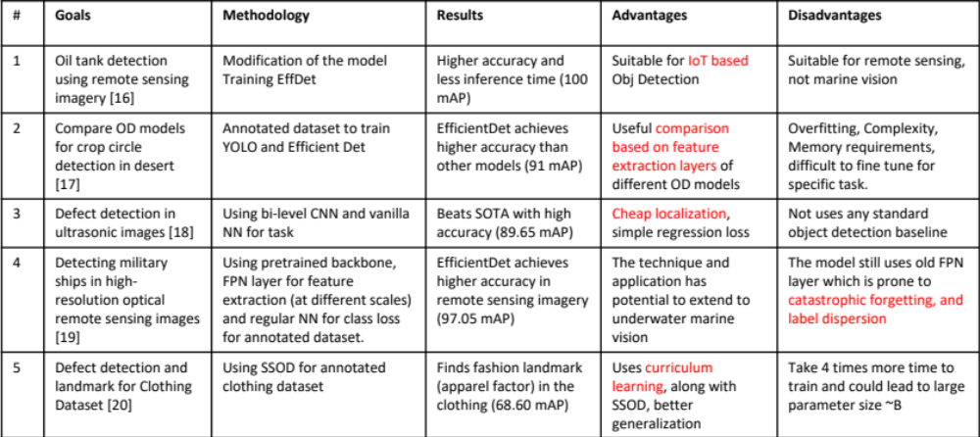
Summary of the related work surveyed is detailed in Table 1.
Table 1 Summary of related work and its key details

4- Methodology

5- Experimental Setup

6- Results

7- Conclusion
References
[1] Nalamati, M., Sharma, N., Saqib, M., & Blumenstein, M. (2020, November). Automated monitoring in maritime video surveillance system. In 2020 35th International Conference on Image and Vision Computing New Zealand (IVCNZ) (pp. 1-6). IEEE.
[2] Prasad, D. K., Prasath, C. K., Rajan, D., Rachmawati, L., Rajabaly, E., & Quek, C. (2016). Challenges in video based object detection in maritime scenario using computer vision. arXiv preprint arXiv:1608.01079.
[3] Prasad, D. K., Rajan, D., Rachmawati, L., Rajabally, E., & Quek, C. (2017). Video processing from electro-optical sensors for object detection and tracking in a maritime environment: A survey. IEEE Transactions on Intelligent Transportation Systems, 18(8), 1993-2016.
[4] Xiao, Y., Tian, Z., Yu, J., Zhang, Y., Liu, S., Du, S., & Lan, X. (2020). A review of object detection based on deep learning. Multimedia Tools and Applications, 79, 23729-23791.
[5] Zhiqiang, W., & Jun, L. (2017, July). A review of object detection based on convolutional neural network. In 2017 36th Chinese control conference (CCC) (pp. 11104-11109). IEEE.
[6] Redmon, J., Divvala, S., Girshick, R., & Farhadi, A. (2016). You only look once: Unified, real-time object detection. In Proceedings of the IEEE conference on computer vision and pattern recognition (pp. 779-788).
[7] Tan, M., Pang, R., & Le, Q. V. (2020). Efficientdet: Scalable and efficient object detection. In Proceedings of the IEEE/CVF conference on computer vision and pattern recognition (pp. 10781-10790).
[8] Bochkovskiy, A., Wang, C. Y., & Liao, H. Y. M. (2020). Yolov4: Optimal speed and accuracy of object detection. arXiv preprint arXiv:2004.10934.
[9] Lin, T. Y., Dollár, P., Girshick, R., He, K., Hariharan, B., & Belongie, S. (2017). Feature pyramid networks for object detection. In Proceedings of the IEEE conference on computer vision and pattern recognition (pp. 2117-2125).
[10] Liu, S., Qi, L., Qin, H., Shi, J., & Jia, J. (2018). Path aggregation network for instance segmentation. In Proceedings of the IEEE conference on computer vision and pattern recognition (pp. 8759-8768).
[11] Tan, M., & Le, Q. (2019, May). Efficientnet: Rethinking model scaling for convolutional neural networks. In International conference on machine learning (pp. 6105-6114). PMLR.
[12] Ren, S., He, K., Girshick, R., & Sun, J. (2015). Faster r-cnn: Towards real-time object detection with region proposal networks. Advances in neural information processing systems, 28.
[13] He, Kaiming, Georgia Gkioxari, Piotr Dollár, and Ross Girshick. "Mask r-cnn." In Proceedings of the IEEE international conference on computer vision, pp. 2961-2969. 2017.
[14] Yuxin Wu and Alexander Kirillov and Francisco Massa and Wan-Yen Lo and Ross Girshick, Detectron2, 2019 facebookresearch/ detectron2.
[15] Pedersen, M., Bruslund Haurum, J., Gade, R., & Moeslund, T. B. (2019). Detection of marine animals in a new underwater dataset with varying visibility. In Proceedings of the IEEE/CVF Conference on Computer Vision and Pattern Recognition Workshops (pp. 18-26).
[16] Xu, S., Zhang, H., He, X., Cao, X., & Hu, J. (2022). Oil tank detection with improved EfficientDet model. IEEE Geoscience and Remote Sensing Letters, 19, 1-5.
[17] Mekhalfi, M. L., Nicolò, C., Bazi, Y., Al Rahhal, M. M., Alsharif, N. A., & Al Maghayreh, E. (2021). Contrasting YOLOv5, transformer, and EfficientDet detectors for crop circle detection in desert. IEEE Geoscience and Remote Sensing Letters, 19, 1-5.
[18] Medak, D., Posilović, L., Subašić, M., Budimir, M., & Lončarić, S. (2021). Automated defect detection from ultrasonic images using deep learning. IEEE Transactions on Ultrasonics, Ferroelectrics, and Frequency Control, 68(10), 3126-3134.
[19] Qin, P., Cai, Y., Liu, J., Fan, P., & Sun, M. (2021). Multilayer feature extraction network for military ship detection from high-resolution optical remote sensing images. IEEE Journal of Selected Topics in Applied Earth Observations and Remote Sensing, 14, 11058-11069.
[20] Kim, H. J., Lee, D. H., Niaz, A., Kim, C. Y., Memon, A. A., & Choi, K. N. (2021). Multiple-clothing detection and fashion landmark estimation using a single-stage detector. IEEE Access, 9, 11694-11704.

